1. **Try the Queue creation using Solace CLI :**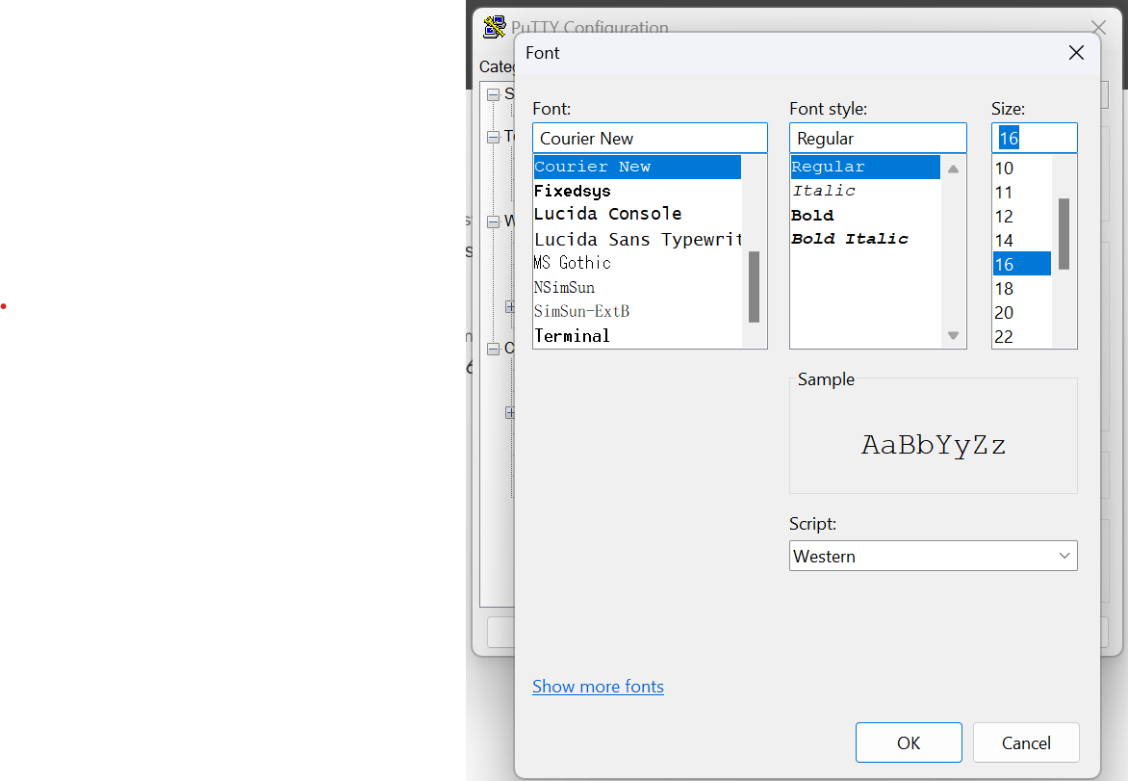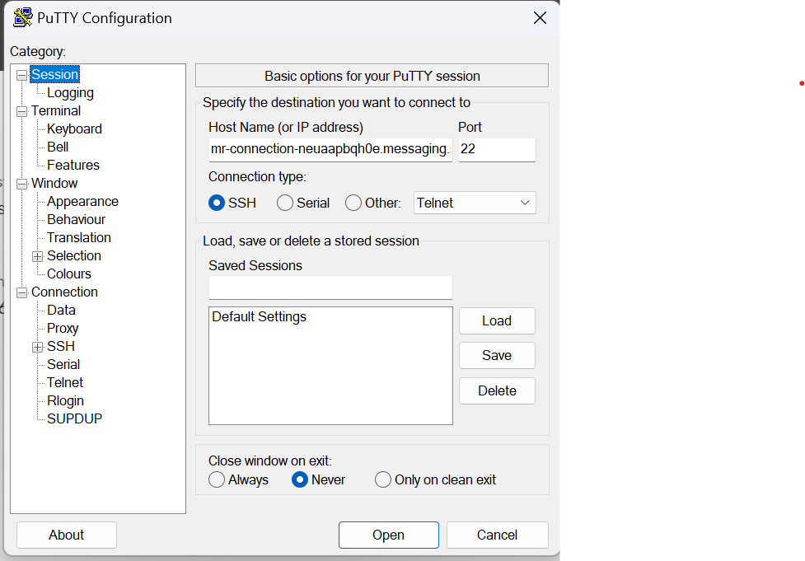

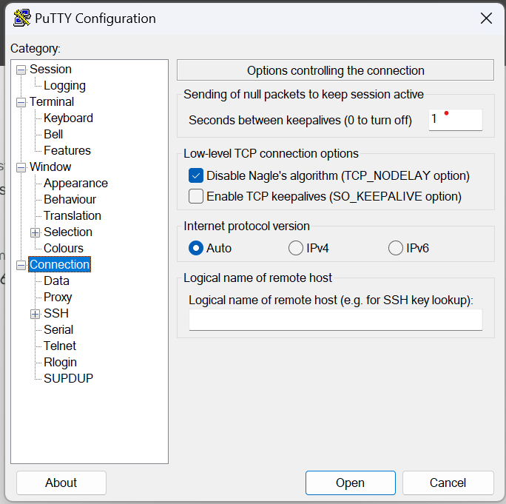

Entering host name and port number to open CLI

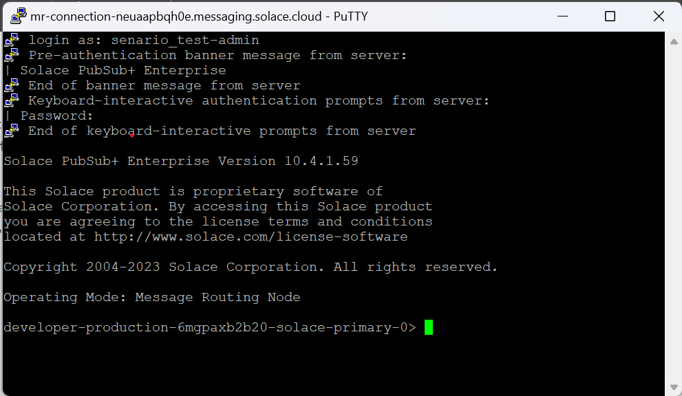

Logging in by entering Management Editor Username and Management Editor password.

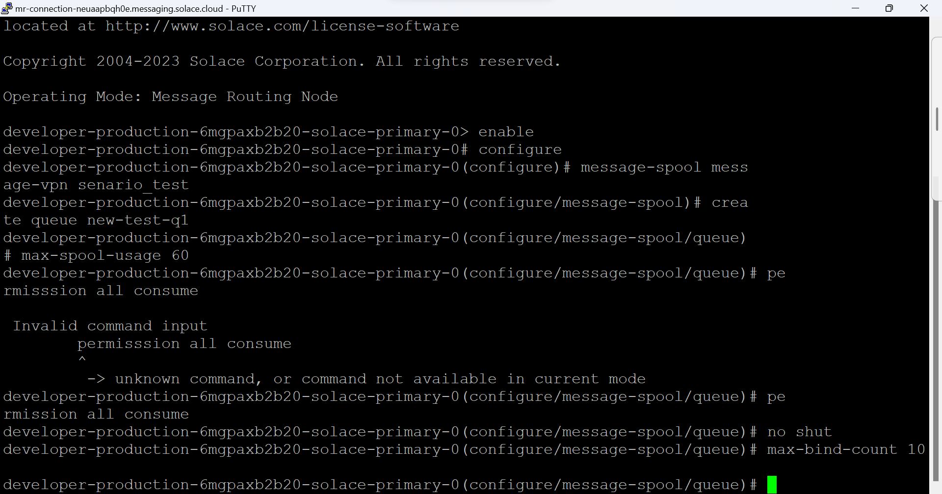

Commands executed to create queue and change some of the properties of the queue.

Command : create queue new-test-q1

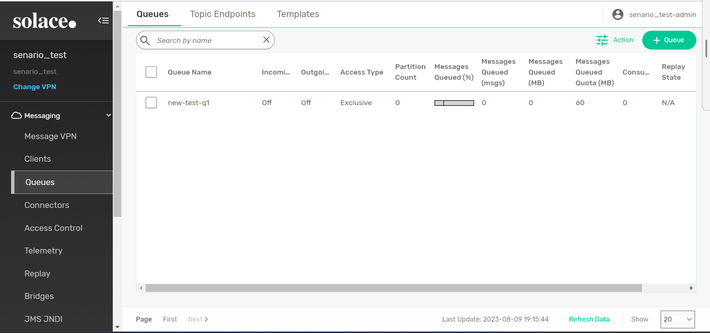

Command : max-spool-usage 60 → max queued data is changed

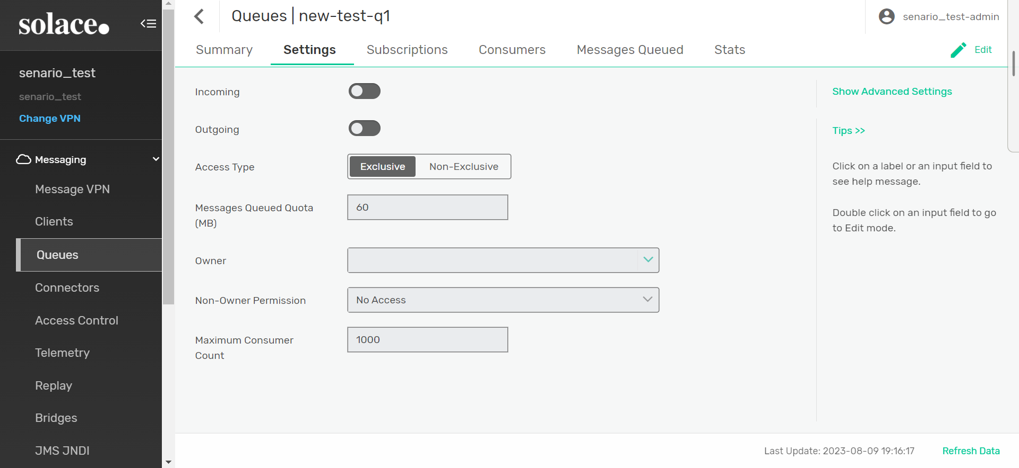

Command : permission all consume → Non-owner permission is changed

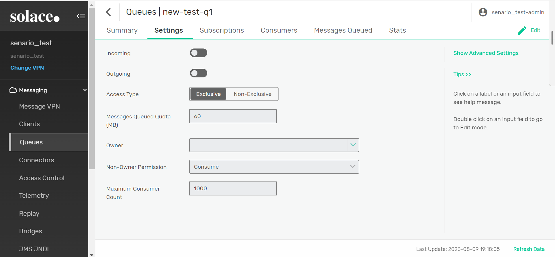

command : no shut → changing into no shut state.

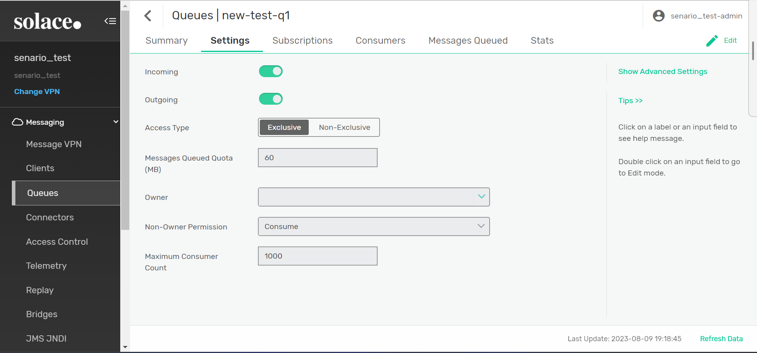

command : max-bind-count 10 → Maximum consumer count is changed.

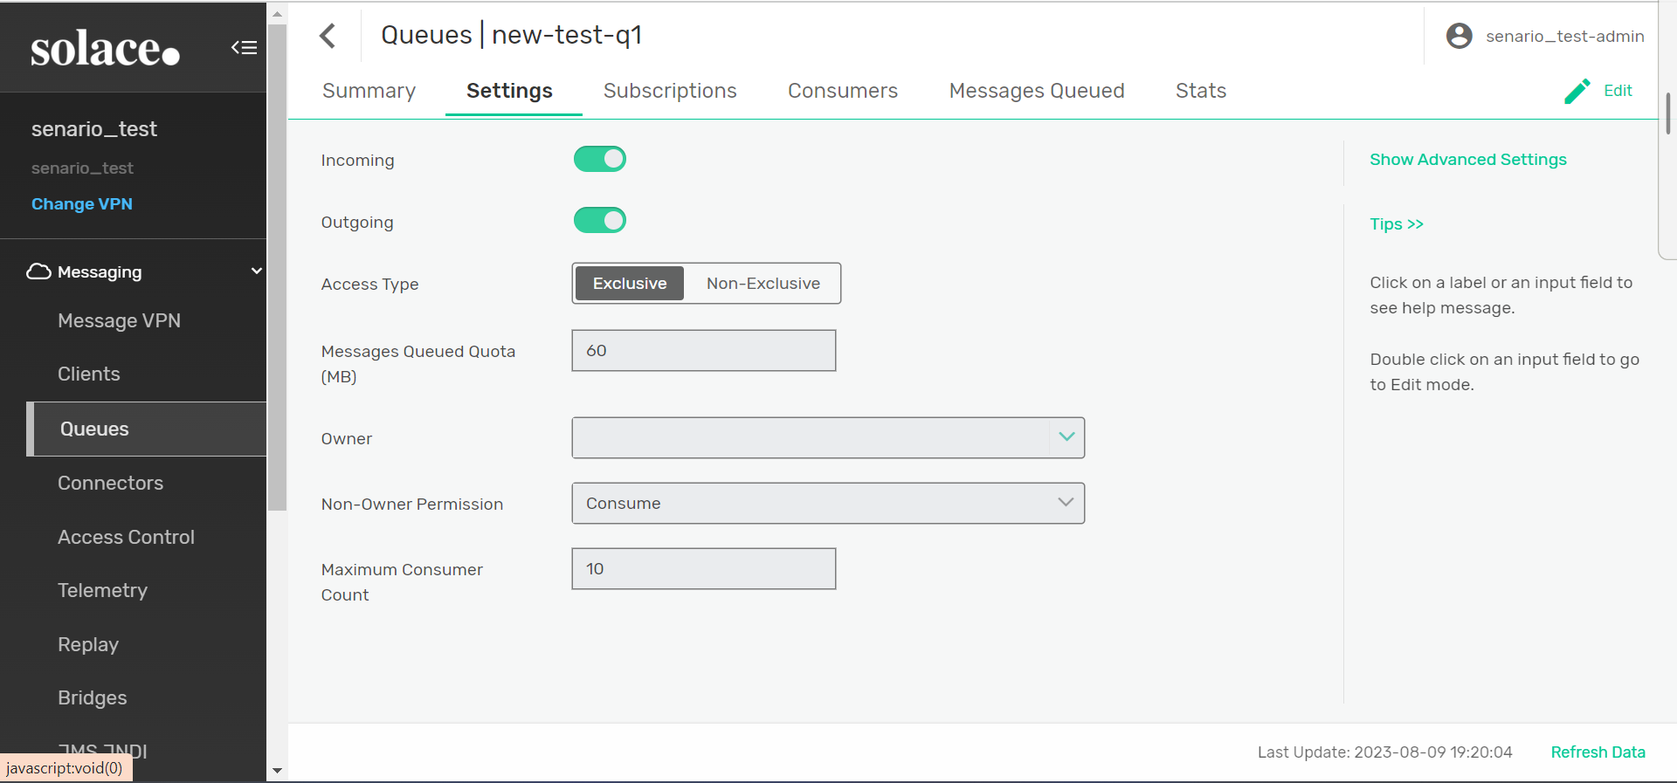

1. **Use the pub-sub services created with Atin and try to populate the queue created using Solace CLI :**

Executing py-publish.py code

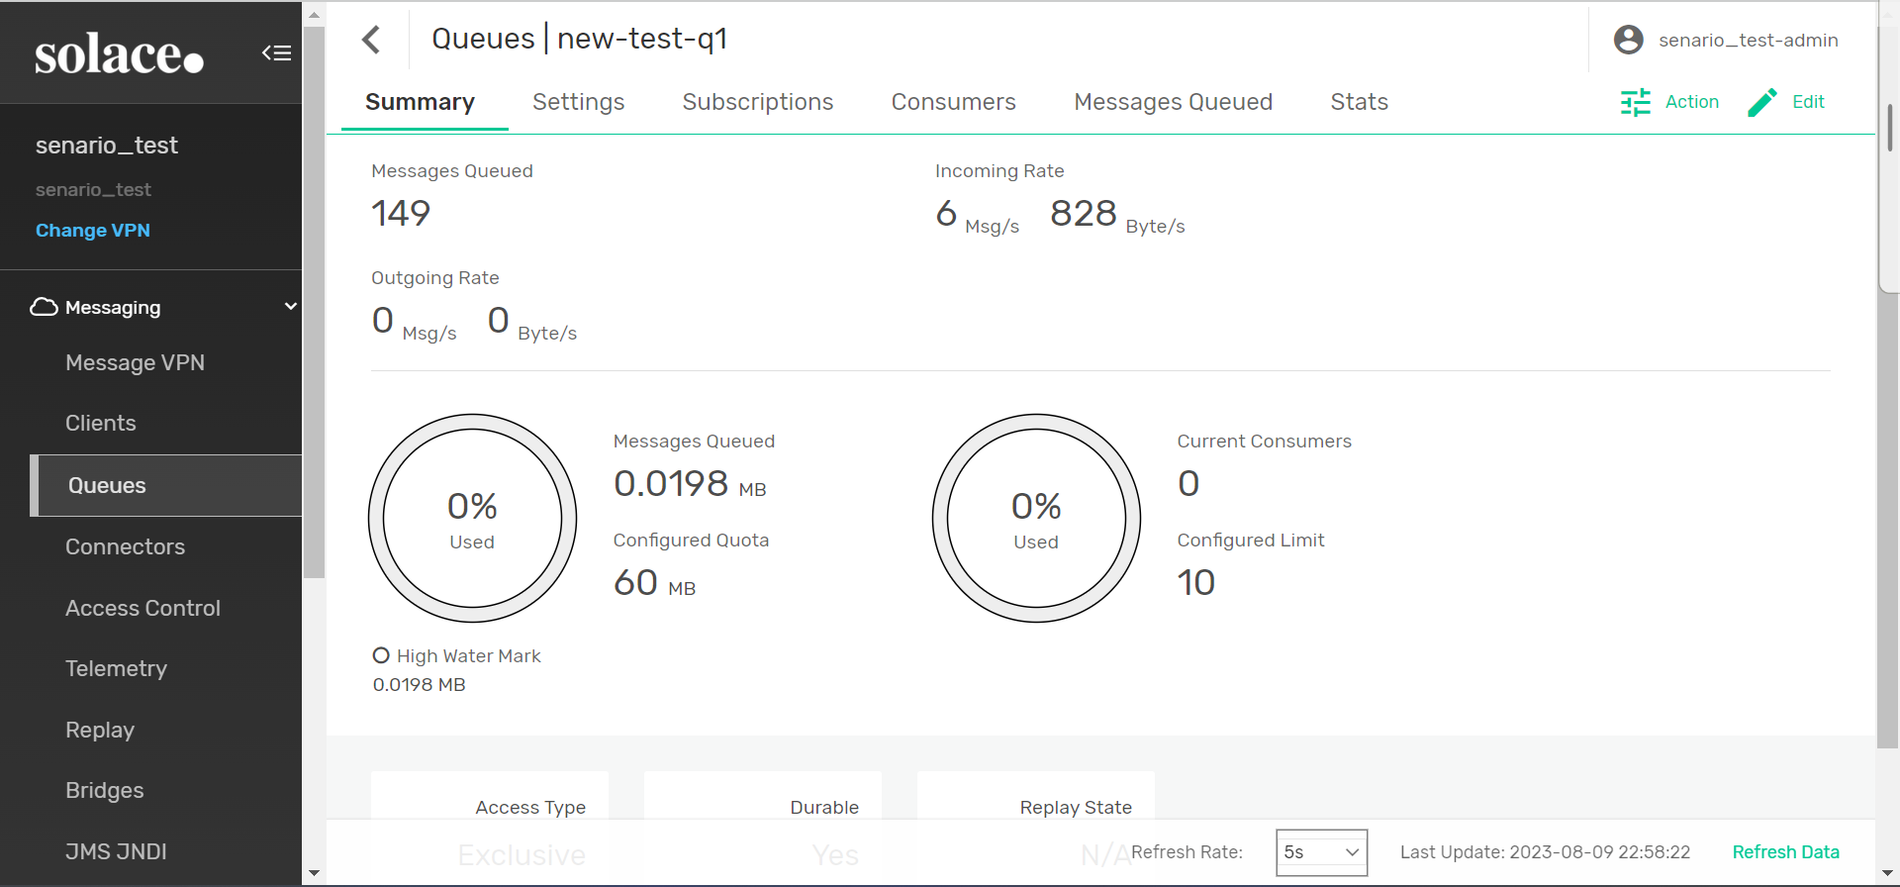

**Practice queue-template creation using WebGUI and Solace CLI with different configurations**

**Template creation using webGUI :**

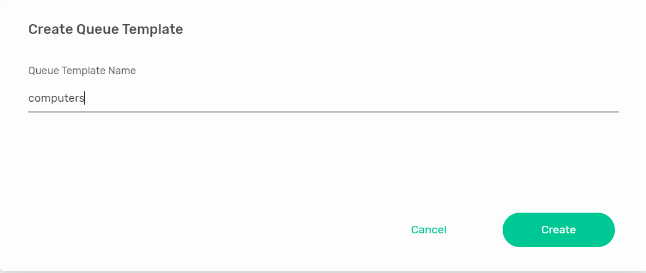

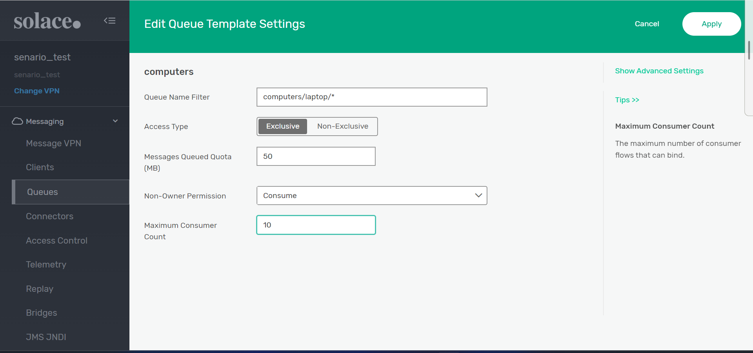

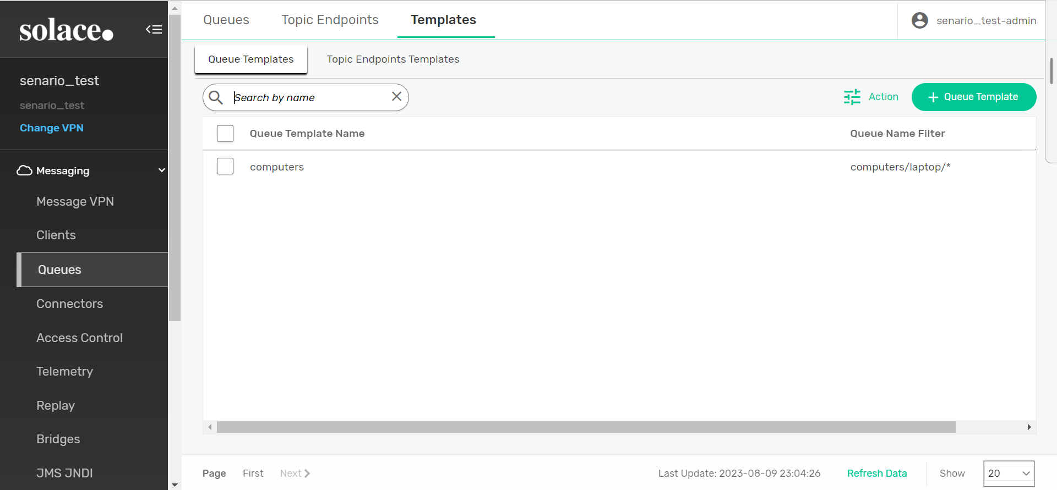

**Using CLI :**

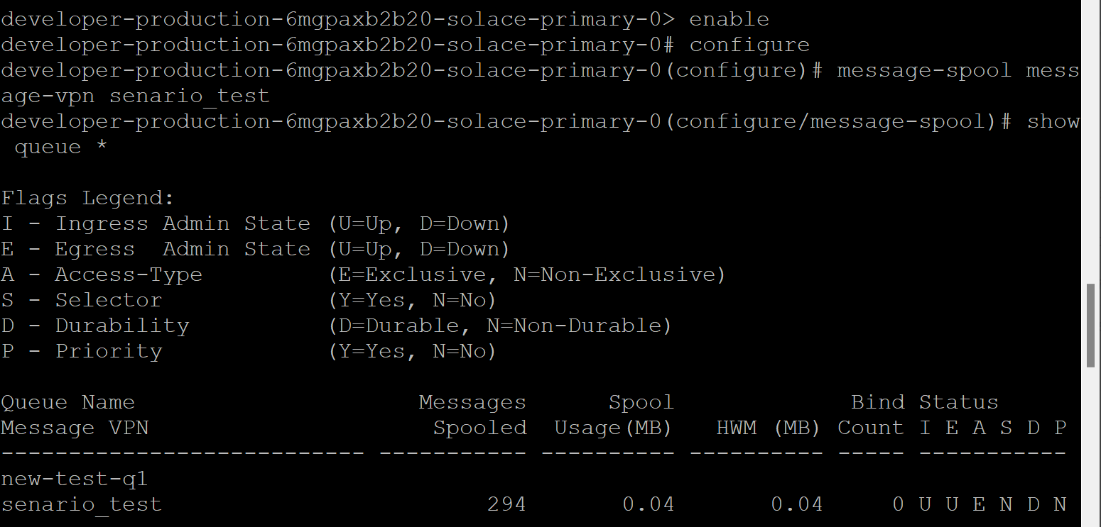

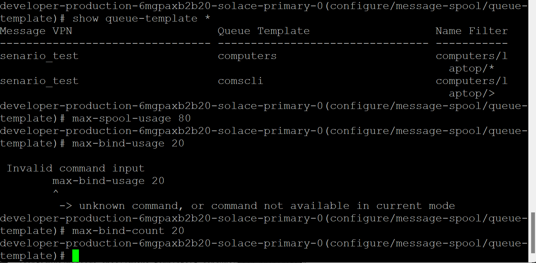

Command : create queue-template comscli → create template named comscli

Command : show queue-template * → shows all the template present in the queue

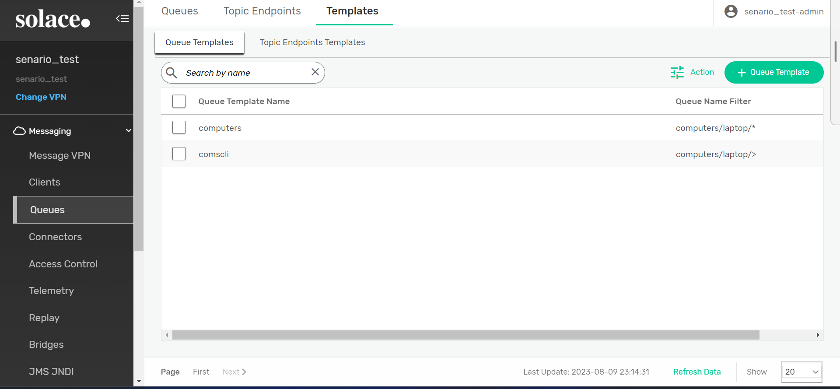

Command : name-filter computers/laptop/> → creating name filter

Command : max-spool-usage 80 → changing Messages Queued Quota to 80 (MB)

Command : max-bind-count 20 → changing Maximum Consumer Count

